OSINT App Project

**Project Management Plan**



Department of Information Technology and Management

November 2023

**Version 1.5**

**Revision History**

Note: The revision history cycle begins once changes or enhancements are requested after the document has been baselined.

| **Date** | **Version** | **Description** | **Author** |
| --- | --- | --- | --- |
| Nov 1, 2023 | 1.0 | Initial version of the OSINT project plan. | Sufyan Khan |
| Nov 1, 2023 | 1.1 | Added more detail to the team communication plan, including the use of Discord and WhatsApp for group discussion | Sufyan Khan |
| Nov 6, 2023 | 1.2 | Project Plan for the next few weeks, including documentation. | Sufyan Khan, Naga Prasath Saravanan,  Rahul Nagaraju, kshiragna challagundla |
| Nov 6 2023 | 1.3 | Gathering Requirements for the software | Josh Reginaldo,  Brahmantya Wardhana,  Kshiragna Challagulla |
| Nov 12, 2023 | 1.4 | Developed Prototype of software application. | Josh Reginaldo, Abhishek Deshpande, Brahmantya Wardhana |
| Nov 15, 2023 | 1.5 | User Interface designed and reviewed. | Josh Reginaldo, Brahmantya Wardhana,  Rahul Nagaraju,  Naga Prasath Saravanan |
| Nov 16, 2023 | 1.6 | Project timetable and milestones have been updated. | Sufyan Khan, Naga Prasath Saravanan,  Rahul Nagaraju, kshiragna challagundla |
| Nov 20, 2023 | 1.7.1 | Fixed bugs in the application identified during testing | Josh Reginaldo,  Abhishek Deshpande, Brahmantya Wardhana |
| Nov 21, 2023 | 1.7.2 | Data collected and analyzed | Kshiragna Challagulla, Rahul Nagaraju |
| Nov 21, 2023 | 1.8 | The project scope and requirements have been revised. | Sufyan Khan, Naga Prasath Saravanan |
| Nov 27, 2023 | 1.9  (Final Release) | Minor changes made to the application to improve clarity and readability. The team reviewed, and the final assessment was done. The application is completed and available for use. | Josh Reginaldo,  Abhishek Deshpande, Brahmantya Wardhana |

**Artifact Rationale**

The Project Management Plan (PMP), according to the Guide to the Project Management Body of Knowledge (PMBOK®), is a formal, approved document used to guide both project execution and project control. The primary uses of the PMP are to document planning assumptions and decisions, facilitate communication among stakeholders, and document approved scope, cost, and schedule baselines. By showing the major products, milestones, activities and resources required on the project, it is also a statement of how and when a project's objectives are to be achieved.

The project manager creates the PMP following input from the project team and key stakeholders. The plan should be agreed on and approved by at least the project team and its key stakeholders.

The PMP is mandatory for all projects. While it is a project-level document, it should be updated as necessary, including for each increment.

**Instructions***.*

| **Activity** | **New Capability (1)** | **Feature Enhancement (2)** |
| --- | --- | --- |
| **Field Deployment (A)** | Yes | Yes |
| **Cloud/Web Deployment (B)** | Yes | Yes |
| **Mobile Application (C)** | Yes | Yes |

**Table of Contents**

**1.** **Introduction 1**

**1.1.** **Project Overview 1**

**1.2.** **Scope Statements 1**

**1.3.** **Goals and Objectives 1**

**1.4.** **Stakeholders and Key Personnel 1**

**2.** **Project Organization 1**

**3.** **Acquisition Process 1**

**4.** **Monitoring and Control Mechanisms 1**

**5.** **Systems Security Plans and Requirements 1**

**6.** **Work Breakdown Structure (WBS) and Schedule 2**

**7.** **Project Success Criteria 2**

**8.** **Communication Management Plan 2**

**9.** **Risk Management Plan 2**

**10.** **Software Configuration Management (SCM) Plan 2**

**11.** **Training Plan 2**

**12.** **Quality Assurance Plan 2**

**13.** **Project Measurement Plan 2**

**13.1.** **Description 3**

**13.2.** **Performance Measurements 3**

**14.** **Reference Materials 5**

**Approval Signatures 6**

**15.** **Project Plan Approval 6**

# Introduction

This PMP describes the project management processes that the OSINT App Project will follow during the execution of the OSINT App project. The project’s processes will align with plans and processes of the Project Management Accountability System (PMAS) Guide. New processes will be defined for any management areas not covered by the PMAS Guide. This PMP will govern the management practices across the life of the project. As those practices evolve, this document will reflect the changes.

## **Project Overview**

The OSINT (Open Source Intelligence) project offers an exhaustive examination of publicly accessible information to enhance decision-making. Its primary objective is to furnish a collection of actionable insights and recommendations derived from the meticulous analysis of OSINT data. The project's focal point is developing a software program tailored to collect and assess data from two social media platforms.

Comprising critical data collection, analysis, and programming tasks, this initiative will involve gathering publicly available information from diverse sources in the data collection phase. Subsequently, specialized tools and techniques will be employed during the analysis phase to extract pertinent insights from the amassed data. The programming stage will involve selecting the desired social media applications and leveraging their Application Programming Interfaces (APIs) to access relevant data.

The project's primary deliverable is a comprehensive report encompassing all insights and recommendations from the OSINT data analysis. Stakeholders will have access to the datasets for further exploration alongside the analytical tools utilized, enabling their utilization in future projects. The project's pivotal milestones include completing data collection, analysis, programming, and reporting phases, complemented by periodic stakeholder check-ins to ensure alignment with project objectives, adherence to deadlines, and provision of status updates. Essential resources for project success encompass a team of skilled analysts proficient in OSINT analysis, specialized software tools for data collection and analysis, and a dedicated project manager ensuring timely deliverables within the specified budget. The project's master high-level schedule will outline timelines for each phase—data collection, analysis, and reporting—determined by the project scope, resource needs, and the envisaged completion timeframe.

## **Scope Statements**

Our scope encompasses creating an adaptable application, initially designed for basic functionalities that can evolve or be seamlessly integrated into a broader dashboard or platform. The application's primary function will display essential data from two currency-related and two geographical-related data sources. This adaptable framework allows for future enhancements and scalability.

For currency data:

Exchange Rate Converter: This API allows users to convert between different currencies by providing current exchange rates and calculating currency conversion.

Crypto Coin Price: This API provides real-time data on cryptocurrency prices, allowing users to track and analyze the values of various cryptocurrencies in the market.

For geographic data:

Sunrise Sunset Data: This API provides information on the sunrise and sunset times for specific locations, allowing users to access data related to daylight hours based on geographical coordinates.

Simple Country Data: This API offers comprehensive information about countries worldwide, including details like population, capital, area, and more.

## **Goals and Objectives**

**Overview of the Project:**

The project aims to evaluate publicly available information to improve decision-making thoroughly. The primary goal is to deliver actionable insights and suggestions based on carefully examining OSINT data.

**Statements of Scope:**

* Create an adaptive application initially developed for essential functions.
* Collect critical information from monetary and geographic data sources.
* Create the application framework with scalability and future improvements in mind.

**Criteria for Project Success:**

* Functionality: Ensure that the software program collects and analyzes data from social media networks, offering actionable insights in an easy-to-use format.
* Maintain efficiency in searching, processing data, and maintaining security compliance.
* Security: Protect user data from unwanted access or modification.
* User Satisfaction: Prioritize user-centric design and constantly utilize feedback to enhance user experience.
* Timeliness: Follow project deadlines and financial limits.

**Communication Management Strategy:**

For project updates and status reports, use Discord and WhatsApp.

Provide regular project status updates to keep stakeholders informed.

**Risk Management Strategy:**

Throughout the project lifetime, identify, assess, and minimize possible risks.

**Training Strategy:**

OSINT, data collecting, and analysis should be taught to data analysts.

Teach web scraper libraries and techniques to software engineers.

**Plan for Quality Assurance:**

* Ensure software requirements compliance, reliability, error-free deliveries, minimal defect density, and user acceptability.
* Implement testing tools, feedback systems for users, and frequent reporting.

**Plan of Measurement for the Project:**

Various metrics and measurements assess project needs, performance, user satisfaction, timeliness, compliance, and resource allocation.

## **Stakeholders and Key Personnel**

**Project Manager:** Sufyan Khan, Naga Prasath Saravanan

The project manager is pivotal in supervising the software program's development, ensuring adherence to the schedule, proficient resource management, and maintaining open communication with stakeholders.

**Software Developer:** Josh Reginaldo, Abhishek Deshpande, Brahmantya Wardhana

A software developer is responsible for crafting the code constituting the software program. Mastery in programming languages like Python or Java is essential for this role.

**Data Analyst:** Kshiragna Challagulla, Rahul Nagaraju

The role of a data analyst encompasses collecting, processing, and thorough analysis of data derived from diverse sources, including social media platforms. A proficient data analyst is expected to possess expertise in utilizing data analysis tools and techniques, encompassing data mining, machine learning, and statistical analysis methodologies.

**User Interface Designer:** Josh Reginaldo, Brahmantya Wardhana

A user interface designer's role encompasses crafting the software program's visual interface. This professional should possess expertise in graphic design tools and a comprehensive understanding of user interface design principles.

**Subject Matter Expert(s):** Josh Reginaldo, Brahmantya Wardhana, Rahul Nagaraju, Abhishek Deshpande, Kshiragna Challagulla, Naga Prasath Saravanan, Sufyan Khan

A subject matter expert possesses extensive expertise in a specific field or industry. Within OSINT software development, such an expert can offer valuable insights into the precise domain or topic the software program targets. Their depth of knowledge contributes significantly to the understanding and advancement of the software's focus area.

# **Project Organization**

Roles and responsibilities of each team member

**Project Manager:** Sufyan Khan, Naga Prasath Saravanan

**Subject Matter Expert(s):** Josh Reginaldo, Brahmantya Wardhana, Rahul Nagaraju, Abhishek Deshpande, Kshiragna Challagulla, Naga Prasath Saravanan, Sufyan Khan

**User Interface Designer:** Josh Reginaldo, Brahmantya Wardhana

**Data Analyst:** Kshiragna Challagulla, Rahul Nagaraju

**Software Developer:** Josh Reginaldo, Abhishek Deshpande, Brahmantya Wardhana

Determine the communication channels that will be used for project updates and status reports.

Our chosen communication channels for these purposes will encompass Discord and WhatsApp.

# **Acquisition Process**

There is no acquisition for the project.

# **Monitoring and Control Mechanisms**

This project follows standard monitoring and control processes defined in ProPath for risk management, traceability, and operational readiness.

# **Systems Security Plans and Requirements**

System security plans and requirements will be developed during the project’s planning phase.

# **Work Breakdown Structure (WBS) and Schedule**

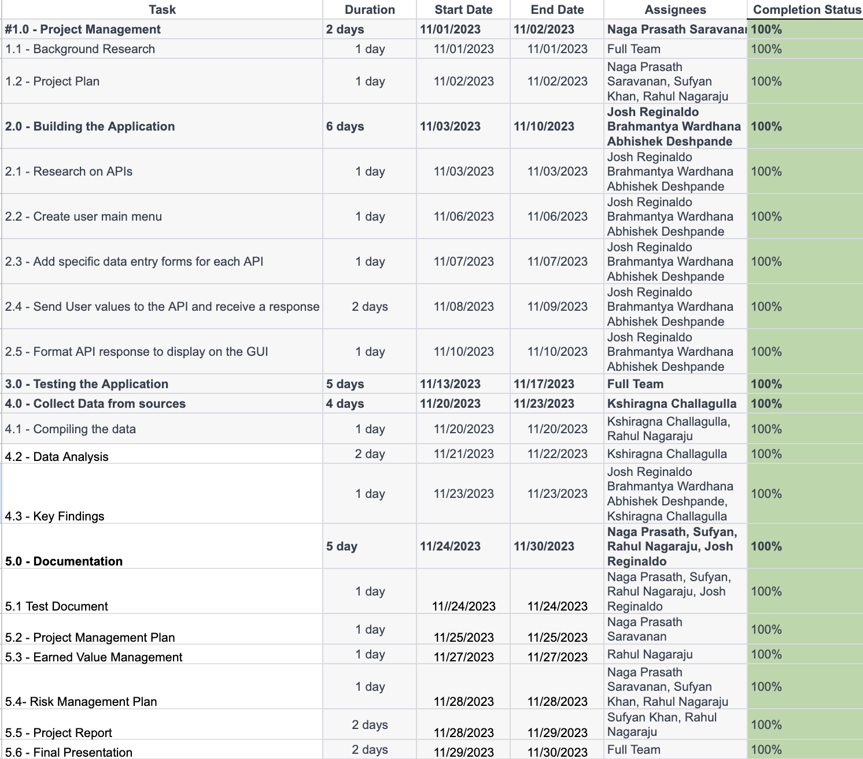

# **Project Success Criteria**

**Functionality:**

The software program is designed to adhere rigorously to the comprehensive functional requirements outlined in the Software Requirements Specification (SRS) document. It stands committed to proficiently collecting and analyzing data from two distinct social media platforms, ensuring the delivery of actionable insights to users. User-friendliness remains a pivotal facet, facilitating ease of interaction and utilization.

**Performance:**

Aligned with the stringent performance standards stipulated in the SRS document, the software can swiftly execute searches for specific keywords, ensuring expedited and efficient data collection. Its capabilities extend to prompt and accurate analysis and processing of collected data, a testament to its performance-driven design.

**Security:**

Emphasizing security as paramount, the software program complies with all security requirements specified in the SRS document. It upholds a robust shield, safeguarding user data against unauthorized access, misuse, disclosure, or alterations.

**User Satisfaction:**

The software's success hinges significantly on user satisfaction. Its user-centric design is tailored to meet and surpass user expectations, offering intuitive functionality and invaluable insights. Rigorous analysis of user feedback constitutes an integral part of our strategy to enhance user satisfaction continually.

**Timeliness:**

The software development endeavors meticulously adhere to project timelines and budgetary constraints. Any potential delays or budgetary deviations will be proactively tracked, managed, and mitigated to ensure the project's on-time delivery within allocated resources.

# **Communication Management Plan**:

Our communication will be facilitated through Discord and WhatsApp. Regular project status updates and reports will be essential to keep all stakeholders abreast of the project's ongoing progress. The frequency and structure of these updates and news will be established during the project planning phase to ensure the effective dissemination of information.

# **Risk Management Plan**

**Handling Risks for the Project:**

For this project, the risks identified and their respective handling strategies are outlined in our Risk Management Log. Each risk is assessed based on its impact, probability of occurrence, and the mitigation plan in place.

**Risk Management Approach**

Understanding and managing potential risks is crucial for ensuring the success and smooth execution of our project, OSINT. We've implemented a comprehensive risk assessment and management strategy to handle and mitigate risks effectively. Our approach includes:

1. **Identification of Potential Risks:**

We initiated the risk assessment by identifying possible risks that could impact the project.

1. **Risk Analysis:**

Analyzed the probability of each identified risk occurring and assessed its potential impact on project outcomes.

1. **Risk Severity Evaluation:**

Determined the severity or gravity of each risk by evaluating the consequences it might have on the project.

1. **Risk Mitigation Strategies:**

Developed practical and efficient strategies to address and mitigate the identified risks.

1. **Continuous Monitoring and Review:**

We reviewed potential vulnerabilities throughout the project lifecycle and adjusted our risk management strategies accordingly.

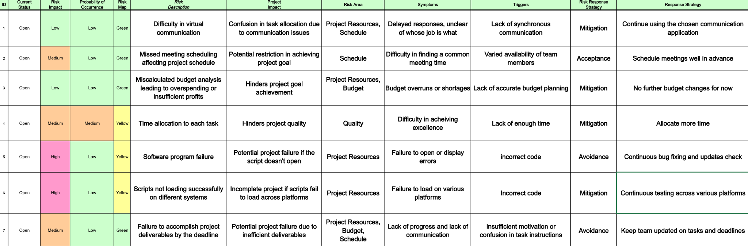

# **Software Configuration Management (SCM) Plan**

We followed the standard SCM plan, i.e., Planning and specifications, Analysis and design, implementation, testing, releasing(to git), maintenance, and repeated process.

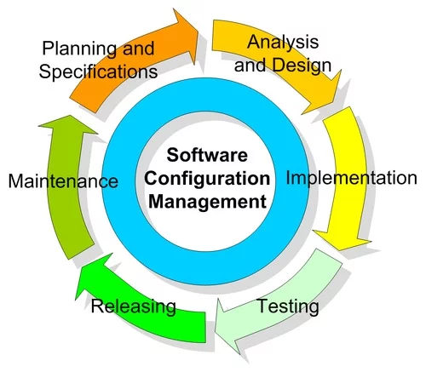

# **Training Plan**

| **Trainee** | **Knowledge Gained** |
| --- | --- |
| Data Analyst | * Introduction to OSINT (Open Source Intelligence) and its significance in data collection. * Training on utilizing the OSINT web scraper application to collect relevant data for analysis. * Explaining the significance of currency and geographic data in the analysis. * Guided, analyzed, and interpreted the gathered data for meaningful insights. |
| Software Developer | * Overview of web scraper libraries and their applications in data extraction. * Training sessions on utilizing various web scraper libraries and techniques for extracting data from different sources. * Demonstrations on effectively integrating and structuring the extracted data into an application framework. * Emphasizing adaptability, scalability, and integrating the extracted data into a broader dashboard or platform. |

# **Quality Assurance**

# **Plan for Quality Assurance**:

The OSINT project's Quality Assurance (QA) Plan explains our strategy for ensuring high-quality software development and deployment. This plan covers several stages of the project's lifespan, focusing on quality checkpoints and techniques to guarantee that outputs match defined criteria.

**Compliance:** Ensured all software requirements, industry standards, and best practices are met.

**Reliability:**

* Ensured the software application's dependability and stability.
* Throughout the software development process, addressed security risks and protected data integrity.
* Improved user satisfaction by emphasizing usability and user-centric design concepts.

**Deliverables with No Errors:** Reduced defects and guaranteed final deliverables match quality requirements.

**Low Defect Density:** Calculated the number of faults found per line of code.

**Test Coverage:** Determines the proportion of code that automated tests have covered.

**Less Bug Resolution Time:** We kept track of how long it took to fix reported bugs.

**User Acceptance:** Collect feedback and satisfaction scores from users.

**Vulnerabilities in Security:** Monitored and remediated security vulnerabilities within defined timeframes.

**Defect Tracking:** Used specialized software to log, track, and manage discovered flaws.

**Testing Tools:** Used automated testing tools to get performance and code coverage information.

**User input:**

* Collected user input regularly via surveys, usability tests, or feedback forms.
* Conducted frequent security scans and audits to discover vulnerabilities.

**Regular Reporting:** During project meetings, reported defect numbers, test coverage, and user input.

**Ad Hoc Reports:** Created ad hoc reports on security vulnerabilities, bug resolution timeframes, and other topics as needed.

# **Project Measurement Plan:**

The Project Measurement Plan specifies how the project's success will be measured to its objectives and requirements. This strategy includes defining measuring objectives, pertinent metrics, data-collecting techniques, and systems for analysis and reporting.

## **Description:**

**Project Requirements:**

* Assess compliance with software requirements and project objectives.
* Project performance is measured in code quality, dependability, and security.

**User Satisfaction:** User satisfaction may be measured using feedback and usability measures.

**Timeliness:** Monitor project progress with project timetables and milestone achievement.

**Metrics that support measurement objectives include**

**Requirement Coverage:**

* Calculate the percentage of requirements that have been met.
* Count the number of problems that have been detected and remedied.

**User Engagement:** Collect user comments and rate usability.

**Timeline adherence:** Monitor project milestones versus scheduled timetables.

**Data Collection and Analysis Requirement Management Tools:**

* Track and manage software needs using tools.
* Use issue-tracking solutions to manage faults and track their resolution.

**User Feedback Mechanisms:** Use surveys, interviews, or feedback forms to collect user feedback.

**Milestone Tracking Tools:** Use project management software to track milestone completion.

**Ad Hoc Reports:** Create one-time reports on urgent issues or departures from schedules.

## **Performance Measurements**:

## **Table 5:** OSINT App Project **Performance Measurements**

| **No.** | **Measurement Name** | **Measurement Objective** | **Metric** |
| --- | --- | --- | --- |
| 1. | Changes in Requirements | During project development, examine the frequency and impact of requirement modifications. | Count the number of requests for requirement changes, categorize them by severity, and monitor their influence on project deadlines and resources. |
| 2. | Rate of Defects | To estimate the number of flaws discovered in each phase or iteration. | Calculate the number of faults discovered in each project phase or iteration vs the volume of work accomplished during that phase or iteration. |
| 3. | Effort to Rework | To quantify the time and effort necessary for rework on deliverables. | Estimate the additional time, resources, and expenses spent on reviewing and correcting previously performed work. |
| 4. | Rate of Acceptance by Users | To determine how quickly consumers embrace the implemented enhancements. | Collect user feedback or conduct surveys to establish the target audience's degree of satisfaction or acceptance of the supplied features. |
| 5. | Achievement of a Milestone | To keep track of the proportion of milestones met within the timeframes set. | Calculate the proportion of milestones achieved on time divided by the total number of planned milestones. |
| 6. | Efficiency of Performance | To assess the overall effectiveness of the software product. | To assess the software's efficiency in accomplishing tasks, and measure system response times, processing speeds, and resource consumption. |
| 7. | Compliance with Requirements | To determine how well the supplied product corresponds to the specifications. | Compare the implemented features to the original specifications, noting any differences or improvements. |
| 8. | Resource Allocation | Throughout the project's lifespan, monitor and optimize resource consumption. | Monitor the utilization of human resources, equipment, and materials in relation to anticipated allocations and budgets. |

# **Reference Materials**

| **Documents** | **Link** |
| --- | --- |
| Project Drive Folder | [*OSINT Folder*](https://drive.google.com/drive/folders/13tE5DzkigdgPj9jdQFXOaL9ZbbOwvtEs?usp=drive_link) |
| Project Management Sheet | [*Project Management Sheet*](https://docs.google.com/spreadsheets/d/1M3FJrv30qBF3O5FZIAEuvHMn6OPgZiEb/edit?usp=sharing&ouid=106342454229757462896&rtpof=true&sd=true) |
| Risk Management Sheet | [*Risk_Management_Log.xlsx*](https://iit0-my.sharepoint.com/personal/skhan125_hawk_iit_edu/Documents/Risk_Management_Log.xlsx?d=w70c54c1ab05d48d5988be0622781b2a4&csf=1&web=1&e=T61E4o) |
| Application Test Document | [*OSINT Test Plan*](https://docs.google.com/document/d/19u0rqJb2960D2n-I5mw0G-i_t9oS6emkvmN98kqScYs/edit?usp=sharing) |
| OSINT Presentation | [*https://docs.google.com/presentation/d/1KZ3YeDEx-tudN70m-4iG3tdiDl2RHnsPsWiB4r2H8Uk/edit?usp=sharing*](https://docs.google.com/presentation/d/1KZ3YeDEx-tudN70m-4iG3tdiDl2RHnsPsWiB4r2H8Uk/edit?usp=sharing) |

**Approval Signatures**

# **Project Plan Approval**

The signatures below indicate that the undersigned:

* Have reviewed the Project Plan.
* Have formally voiced applicable concerns to the PM.
* Concur that the Project Plan accurately represents their expectations and conditions required for the project.
* Are committed to providing the required resources.
* Are unaware of undocumented conditions that prevent the success of this project.

REVIEW DATE: December 1st, 2023

SCRIBE: Sufyan Khan, Naga Prasath Saravaran

Signed: Sufyan Khan, Naga Prasath Saravaran

Project Manager Date: December 1st, 2023

Signed:

Business Sponsor Date